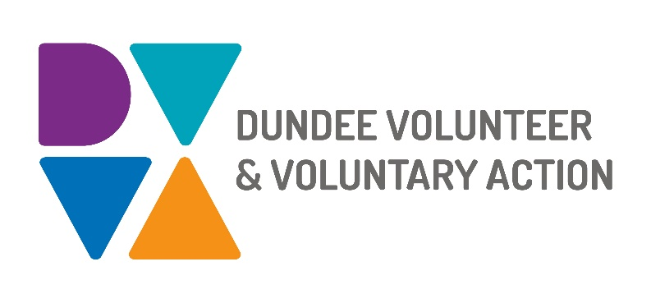

Job Description and Person Specification
POST TITLE: Manager (Mental Health and Substance Use)
DURATION: Permanent subject to initial 6 months probationary period
HOURS OF WORK: 35 hours per week, to be worked in accordance with DVVA Conditions of Service.
SALARY: £32,000
PURPOSE OF POST: To provide leadership, support, and line management to the Mental Health and Substance Use Team, ensuring the effective delivery of engagement activities in line with the mental health and substance use service specification, while also leading the development and implementation of the team’s workplan in alignment with strategic priorities. This role supports people affected by mental health and substance use, alongside third sector organisations, to act as equal and expert partners in making Dundee a city where recovery is possible

MAIN DUTIES

Team Management Responsibilities

- Ensure the effective recruitment, support, and management of staff and volunteers to enable delivery of the team’s work plan.
- Line manage staff as identified by the Head of Service / Deputy CEO.
- Ensure all staff maintain up-to-date work plans aligned with DVVA’s strategic plan and the mental health and substance use service specification requirements.
- Lead and oversee the monitoring, evaluation, and reporting of the team’s activities and impact.
- Support the financial sustainability of the service by identifying and securing funding opportunities, and by developing good working relationships with commissioners.
- Work in partnership with the Finance Manager to develop, manage, and monitor service budgets, ensuring resources are used effectively and in line with organisational and funder requirements.
- Oversee budget management across the service areas, maintaining financial oversight, identifying risks, and supporting informed decision-making to ensure sustainability and value for money.
- Carry out any other duties appropriate to level of the post, as directed by the Head of Service / Deputy CEO and the Chief Executive.

Service-specific Responsibilities

- Establish and maintain effective strategic relationships across multi-agency partnerships and planning groups, representing the organisation and wider third sector to ensure lived and living experience shapes service design and delivery.
- Work collaboratively with a wide range of stakeholders, including the Health and Social Care Partnership, third, independent, and statutory sectors, and local communities.
- Lead on the delivery of agreed strategic actions across mental health, substance use, and suicide prevention delivery plans, ensure contracted outcomes are met and contribute to wider system priorities.
- Contribute to the delivery of shared outcomes aligned with local and national strategies relating to mental health, substance use, peer support, engagement and participation and suicide prevention.

General Duties

- Use IT systems provided for recording, monitoring, and communication purposes.
- Ensure accurate recording of attendance, outputs, and outcomes to clearly evidence activity undertaken and its impact.
- Actively and constructively participate in both internal and multi-agency meetings, providing leadership through chairing and facilitation where required to support effective collaboration and delivery.
- Contribute to shared team projects and developments including new and ongoing tests of change.
- Work with team colleagues to ensure our plan and its delivery reflects the needs of individuals, organisations, and communities.
- Strive to maintain excellent practice in co-production.
- Demonstrate commitment to the work of Dundee Volunteer and Voluntary Action and the Third Sector Interface. Practice and promote team and partnership working.
- Work in accordance with the organisation’s policies and procedures. Pay particular attention to those relating to lone working, risk assessment, and safeguarding.
- Identify any areas of risk and advise on improvements
- Undertake personal and professional development as required by the role
OTHER DUTIES
The job description is a broad picture of the post at the date of preparation. It is not an exhaustive list of all possible duties as it is recognised that jobs change over time. Should the duties change radically then the post and grading will be reviewed.
CONDITIONS OF SERVICE
- These are set out in the organisation’s staff handbook.
- All staff meeting the qualifying criteria may join a defined contribution pension scheme provided by TPT Retirement Solutions.
- The organisation has an equal opportunities policy and seeks to be an equal opportunities employer.
ANNUAL LEAVE: 21 days per annum on appointment increasing each year by 1 day to a maximum of 25 days, plus 6 public holidays, plus 5 days Christmas and New Year/festive holiday closedown.
LOCATION: Our main office is based at No 10 Constitution Road, Dundee city centre.

DUNDEE VOLUNTEER AND VOLUNTARY ACTION

Manager (MH & SU) - Person Specification

 | Essential | Desirable
Professional/Educational Qualifications
Relevant degree level qualification | X
Practical experience supervising/managing a team in a similar field. | X
Knowledge and Experience
Good working knowledge of mental health and substance use legislation, policy, and frameworks at national, regional, and local levels. | X
An excellent knowledge of engagement and participation practice. | X
Experience in project and programme management, including planning, delivery, and review. | X
Understanding of workforce development and supporting team learning. |  | X
A good understanding of equality and diversity issues and a commitment to addressing inequalities | X
Experience of programme leadership, including staff supervision and support. | X
Experience of working with cross-sector partners, including public and third-sector organisations. | X
Experience of applying for external funding and contributing to funding bids. |  | X
Skills and Abilities
Effective Leadership skills. | X
Ability to present ideas and reports clearly to a range of audiences. | X
Ability to build and maintain working relationships to support shared objectives. | X
Ability to effectively monitor and evaluate work and produce high quality impactful reports. | X
Ability to plan and manage own workload. | X
Competence in using Microsoft Office and other ICT systems. | X
Personal Qualities
Motivated and reliable in approach to work. | X
Able to work as part of a team. | X
Flexible in response to changing demands. | X
Able to work under pressure and manage challenges. | X
Maintains personal and professional integrity. | X
Able to prioritise tasks effectively. | X

Additional job-related requirements
Satisfactory PVG Check | X
Driving licence and access to car |  | X
A commitment to equal opportunities for all, tackling disadvantage and promoting diversity | X

EMPLOYEE BENEFITS AT DVVA
Work/Life Balance
Generous annual leave and public holidays, including 2 week shutdown over Christmas/New Year.
Increased annual leave entitlement based on length of employment.
Right to request flexible working from day 1.
You/Your Family
Enhanced sick pay entitlement.
Increased sick pay entitlement based on length of employment.
Finances
Generous pension contributions.
Opportunities at Work
Opportunities to undertake training relevant to your role and professional/personal development.
Recognition agreement with UNITE giving you legal support and much more.
Support for staff wellbeing

